**Matchmaking Architecture**

Doosung Jang, 101175013

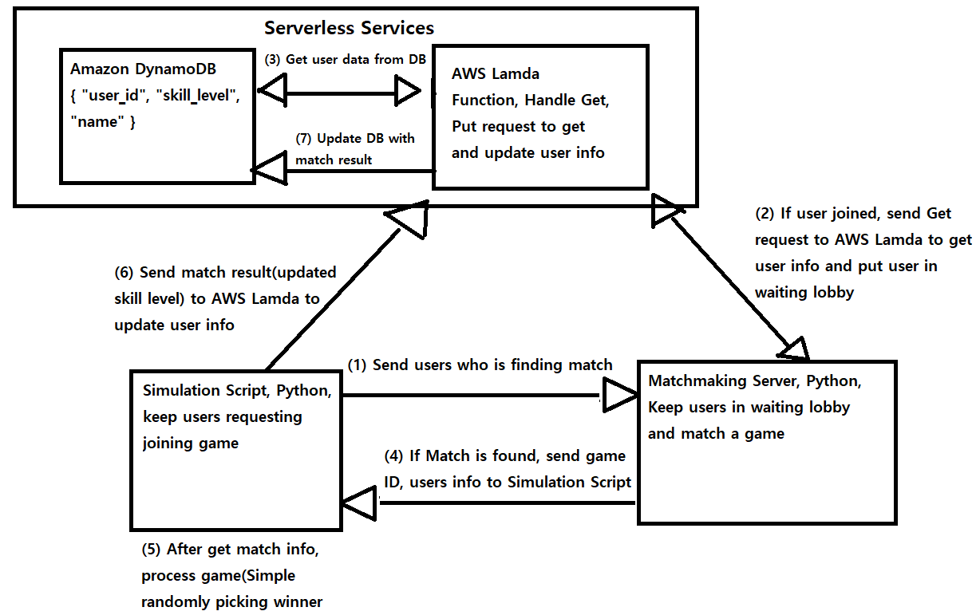

1. First Simulation Script gets input of number of game. This will be how many games will be matched and run. Simulation Script has thread that keeps sending users to Matchmaking Server to find a match.

2. When Matchmaking Server gets user, it request user’s detail information to Serverless Services(Lamda function) using user ID. After it gets user’s information, it put user to waiting line based on user’s skill level.

3.Serverless Services(Lamda Function) get user’s info from DB and send it back to Matchmaking Server.

4. After several (1~3) steps happened, there will be enough users in waiting line. Matchmaking Server has waiting lobby thread which keeps checking if there are enough users in waiting line. Once waiting lobby thread detect enough users in line, it makes a game with those users and send game ID and users to Simulation Script.

5.If Simulation Script gets match information(gameID, users), it runs game(simple randomly picking winner)..

6.Once game has finished, it will send result of the game to Serverless Services.

7.Serverless services will send result of the game to DB to update users’ info.